HR ANALYTICS DASHBOARD
Employee Attrition Analysis Case Study
Tools Used: Excel | Power BI | Tableau | SQL

Metric | Value
Total Employees | 1,470
Attrition Count | 237
Attrition Rate | 16.12%
Active Employees | 1,233
Average Age | 37 years

Prepared by: Brijesh Maurya

1. Executive Summary
This HR Analytics project analyzes employee attrition data to understand why employees are leaving the organization and which employee groups are most affected. The project uses Excel, Power BI, Tableau and SQL to clean, validate, analyze and visualize HR metrics.
The dashboard shows 1,470 total employees, 237 attrition cases, an attrition rate of 16.12%, 1,233 active employees and an average employee age of 37 years. The highest attrition is visible in the Sales department, followed by R&D and HR. Attrition is also higher in the 25-34 age group and among employees from Life Sciences and Medical education fields.

2. Problem Statement
Employee attrition is a major challenge for organizations because it directly affects productivity, hiring cost, employee morale and business continuity. When employees leave the company, HR teams need to understand the reasons behind attrition and identify which employee groups are at higher risk.
In this project, the objective is to analyze employee attrition data and find important patterns based on department, gender, age group, education field, job role, marital status, job satisfaction and other HR factors. The analysis helps HR teams understand where attrition is happening the most and supports data-driven decisions to improve employee retention.

3. Business Objective
- Measure overall employee attrition and active employee count.
- Identify departments, job roles and age groups with high attrition.
- Analyze employee attrition by gender and education field.
- Evaluate job satisfaction distribution across different job roles.
- Validate dashboard KPIs using SQL queries.
- Provide actionable recommendations to reduce employee turnover.

4. Dataset Overview
The dataset contains employee-level HR information including demographic details, job-related attributes, satisfaction ratings and attrition status.
Category | Important Fields
Employee Identity | Employee Number, Employee Count, Over18
Demographics | Age, Age Band, Gender, Marital Status, Education, Education Field
Job Details | Department, Job Role, Job Level, Business Travel, Over Time
Compensation | Monthly Income, Monthly Rate, Daily Rate, Hourly Rate, Percent Salary Hike
Experience | Total Working Years, Years At Company, Years In Current Role, Years Since Last Promotion
Satisfaction | Job Satisfaction, Environment Satisfaction, Relationship Satisfaction, Work Life Balance
Target Variable | Attrition, Attrition Label, Attrition Count, Attrition Rate, Current Employee

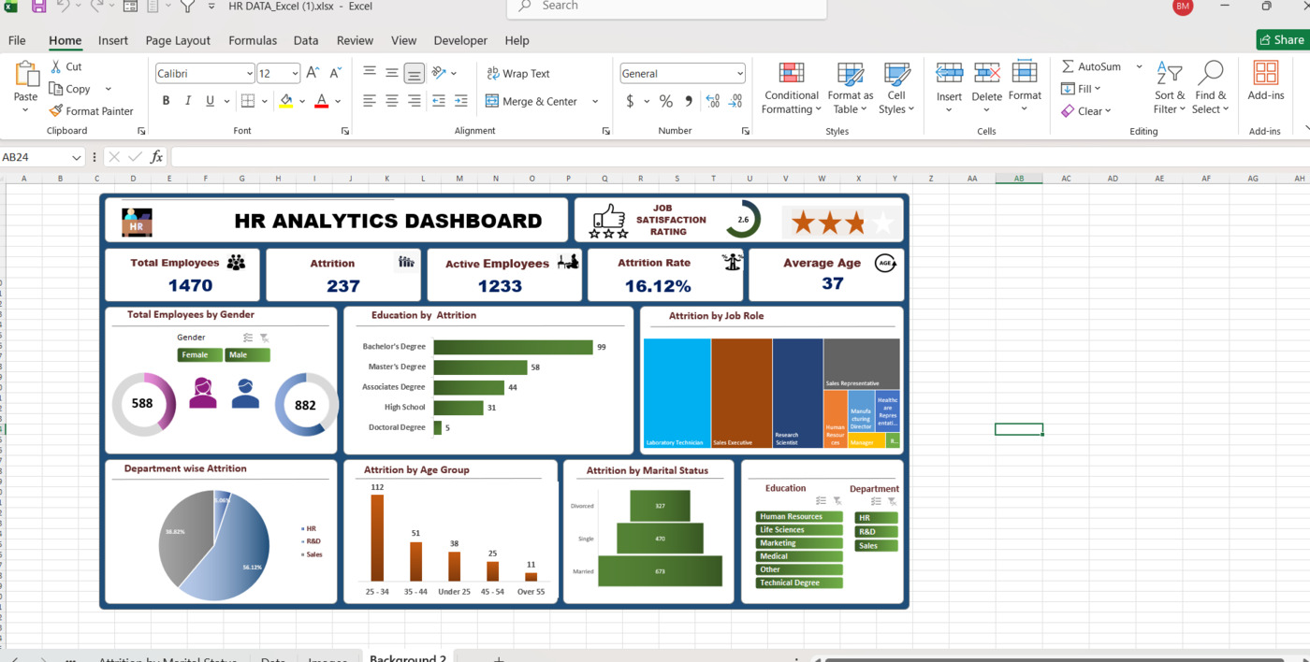
Figure 1: Excel HR Analytics Dashboard

6. Power BI Dashboard View

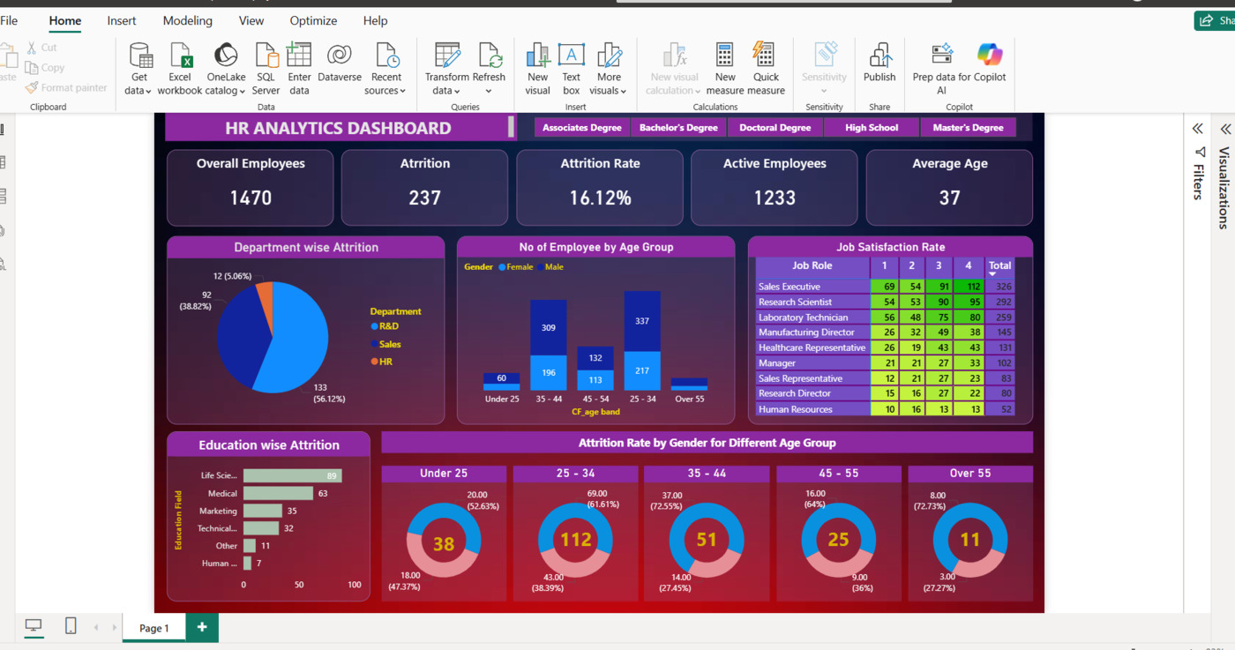
Figure 2: Power BI HR Analytics Dashboard

7. Tableau Dashboard View

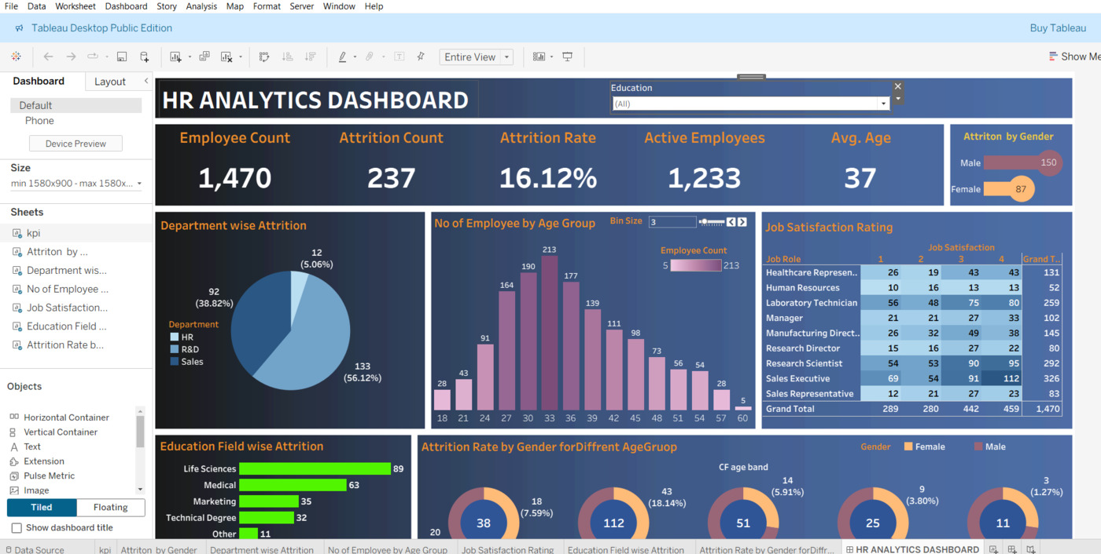
Figure 3: Tableau HR Analytics Dashboard

8. SQL Validation and KPI Calculation
SQL was used to validate the key performance indicators shown in the dashboards and to test whether the dashboard values match the database output.
KPI / Analysis | SQL Logic Used
Employee Count | SUM(employee_count)
Attrition Count | COUNT(attrition) WHERE attrition = 'Yes'
Attrition Rate | Attrition Count / Total Employee Count * 100
Active Employees | Total Employees - Attrition Count
Average Age | ROUND(AVG(age), 0)
Department-wise Attrition | GROUP BY department WHERE attrition = 'Yes'
Education Field-wise Attrition | GROUP BY education_field WHERE attrition = 'Yes'
Age Group and Gender Attrition | GROUP BY age_band, gender
Job Satisfaction Rating | Crosstab by job_role and job_satisfaction

Sample SQL Queries

Employee Count
SELECT SUM(employee_count) AS employee_count
FROM hrdata;

Attrition Count
SELECT COUNT(attrition) AS attrition_count
FROM hrdata
WHERE attrition = 'Yes';

Attrition Rate
SELECT ROUND(((SELECT COUNT(attrition) FROM hrdata WHERE attrition = 'Yes') / SUM(employee_count)) * 100, 2) AS attrition_rate
FROM hrdata;

Department-wise Attrition
SELECT department, COUNT(attrition) AS attrition_count,
ROUND((CAST(COUNT(attrition) AS numeric) /
(SELECT COUNT(attrition) FROM hrdata WHERE attrition = 'Yes')) * 100, 2) AS percentage
FROM hrdata
WHERE attrition = 'Yes'
GROUP BY department
ORDER BY attrition_count DESC;

Education Field-wise Attrition
SELECT education_field, COUNT(attrition) AS attrition_count
FROM hrdata
WHERE attrition = 'Yes'
GROUP BY education_field
ORDER BY attrition_count DESC;

9. Key Insights from Dashboard
Area | Observation | Business Meaning
Overall Attrition | 237 employees left the company out of 1,470 employees. Attrition rate is 16.12%. | HR needs to focus on retention strategies to reduce turnover.
Department | Sales has the highest attrition count with 133 employees, followed by R&D with 92 and HR with 12. | Sales department should be analyzed deeply for workload, targets, salary and growth opportunities.
Gender | Male attrition count is 150 and female attrition count is 87. | Gender-level analysis can help HR understand differences in employee experience.
Age Group | The 25-34 age group has the highest attrition count of 112. | Young and mid-career employees may need better growth paths and engagement programs.
Education Field | Life Sciences and Medical education fields show higher attrition counts. | HR can review role fit, career progression and training needs for these groups.
Job Satisfaction | Job satisfaction varies across job roles, with different roles showing low-to-high satisfaction ratings. | Low satisfaction roles should be monitored for retention risk.

10. Recommendations
- Focus on the Sales department first because it has the highest attrition contribution.
- Create retention programs for employees in the 25-34 age group, such as career growth plans, mentorship and learning opportunities.
- Review compensation and promotion policies for high-risk job roles and employee segments.
- Monitor job satisfaction regularly and take feedback from employees with lower satisfaction ratings.
- Analyze overtime, work-life balance and workload pressure to identify burnout risk.
- Use the dashboard regularly as an HR monitoring tool to track attrition trends month by month.

11. Project Workflow
Step | Work Done
1. Data Understanding | Reviewed HR dataset columns and understood the attrition target variable.
2. Data Cleaning | Checked missing values, duplicates, data types and inconsistent values using Excel and Power Query.
3. SQL Analysis | Created table, imported data and wrote SQL queries for KPI validation and grouped analysis.
4. Dashboard Creation | Built dashboards in Excel, Power BI and Tableau using KPI cards, charts, slicers and filters.
5. Insight Generation | Analyzed attrition by department, gender, age group, education field and job role.
6. Recommendation | Suggested HR actions to reduce employee attrition and improve retention.

12. Conclusion
The HR Analytics Dashboard provides a clear view of employee attrition and helps identify the most affected employee segments. The analysis shows that attrition is concentrated in specific departments, age groups and education fields. By using SQL for validation and dashboards for visualization, HR teams can take data-driven actions to improve employee satisfaction and reduce attrition.

